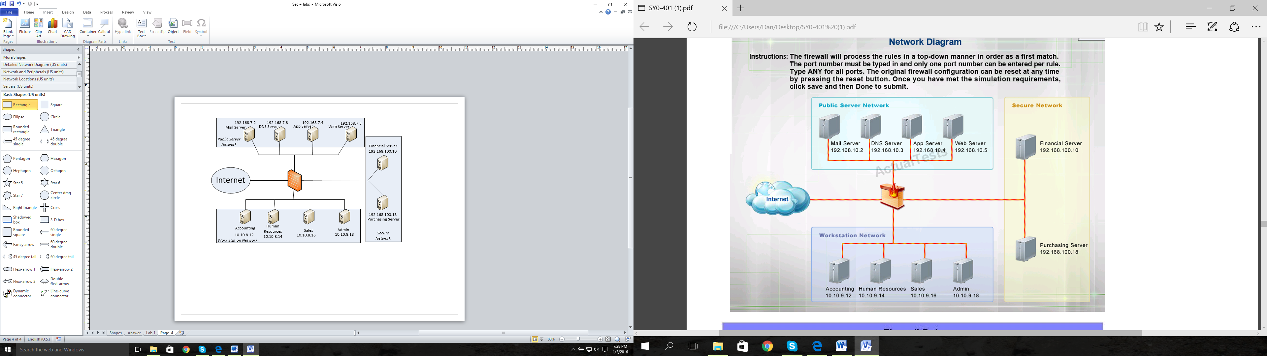

4

3

2

1

You are the head firewall technician and you are sitting down with your management personnel. You and your company are emplacing a new firewall on your network to maximize security and efficiency based on procedural goals at the last conference. Follow the guidance below…

In one statement, prevent each Secure Network host from accessing the Public Server Network at 192.168.7.0 /28.   
Block people from the internet from presenting DNS requests on your network.  
Block Ping Traffic from entering the network from outside users.   
Allow People from the Internet to access the Web Server for secure and unsecure web browsing.   
Allow people from the Workstation Network to access to the Mail Server via SMTP.   
Prevent Internet people from accessing the Financial and Purchasing Server Individually.   
Allow Accounting access to the Financial Server and Purchasing Server through SSH.   
Explicitly Deny all traffic from the Internet as the final statement.

There are 11 total types of firewall statements you must create. Place them in order from top to bottom as depicted in the above tasking statements. Place the statement at the interface where it will prevent Drop traffic from entering the firewall as no outbound port ACL are allowed in this scenario.

|  |  |  |  |  |  |
| --- | --- | --- | --- | --- | --- |
|  | Click below and select from the Scroll Menu | Click below and select from the Scroll Menu | ***Type Port if needed*** | ***Type TCP or UDP or ICMP or Any*** | ***Type Deny or Permit*** |
| ***Inbound*** | ***Source*** | ***Destination*** | ***Port*** | ***Protocol*** | ***Action*** |
| Choose an item. | Source | Destination |  |  |  |
| Choose an item. | Source | Destination |  |  |  |
| Choose an item. | Source | Destination |  |  |  |
| Choose an item. | Source | Destination |  |  |  |
| Choose an item. | Source | Destination |  |  |  |
| Choose an item. | Source | Destination |  |  |  |
| Choose an item. | Source | Destination |  |  |  |
| Choose an item. | Source | Destination |  |  |  |
| Choose an item. | Source | Destination |  |  |  |
| Choose an item. | Source | Destination |  |  |  |
| Choose an item. | Source | Destination |  |  |  |